Title: Interpretable Landslide Segmentation with U-Net Variants: From Baseline to Attention-Driven Deep Models
Authors: Nana Kwaku¹, Ebenezer Nortey¹, Jeremiah Ayok Ishaya¹, Julius Amegadzie¹
Affiliation: ¹ Department of Computational Sciences, Academic City University, Accra, Ghana
Abstract: Landslides continue to threaten rural communities in Ghana, particularly in the Eastern, Western, and Volta regions. This thesis developed an interpretable deep learning system for landslide detection using satellite imagery, beginning with a standard U-Net and progressively enhancing it with ASPP, a six-channel ResNet50 encoder, and CBAM. These upgrades led to steady improvements in validation F1-score from 0.67 to 0.71. Key terrain indicators such as slope, soil colour, and vegetation stress were consistently highlighted across interpretability methods like Grad-CAM, LIME, and sensitivity analysis ensuring that the model’s predictions are both accurate and geologically meaningful. The training pipeline was optimized for GPU efficiency and reproducibility. Despite strong performance, issues like class imbalance and regional generalization remain areas for future improvement. This project ultimately delivers a transparent, accurate landslide detection framework that meets the urgent needs of Ghana’s disaster management teams.
Keywords: U-net, remote sensing, interpretability, satellite imagery

1. Introduction

The United States Geological Survey (USGS) Landslide Handbook describes landslides to be the downslope movement of soil, rock, and organic materials under the effects of gravity and also the landform that results from such movement [14]. Mountain ranges across all continents regularly experience landslides, presenting major hazards to nearby populations. These devastating events are primarily set off by major earthquakes, heavy rains, volcanic events, and human activities, particularly the construction of roads across hillsides. Among these triggers, earthquakes and intense rainfall emerge as the dominant forces behind most landslides, causing destruction across vast territories with events ranging from minor to massive in scale [15]. In Ghana, steep terrain along rivers and mountainous regions, coupled with heavy seasonal rainfall, exacerbates landslide risk, leading to substantial economic and social impacts in affected communities [1]. Traditional manual mapping of landslide-prone areas is time-consuming and often lacks the spatial resolution needed for early-warning systems. Recent advances in deep learning, particularly convolutional neural networks (CNNs) such as U‑Net, have shown promise for automated segmentation of landslide-affected regions using multispectral satellite imagery [2]. Convolutional neural networks are a class of models that are able to learn spatial relationships during the training process and are therefore an apt choice for the landslide detection task [14]. However, the challenge lies in teaching these systems to distinguish subtle signs of potential landslides from the surrounding landscape. Imagine trying to spot a small crack in a mountainside from hundreds of kilometers above Earth. The task becomes even more demanding when dealing with varied terrain types, where landslide indicators might look different depending on the local geography and vegetation [7]. Furthermore, the “black-box” nature of many CNN architectures hampers stakeholder trust and limits practical adoption in disaster management [3]. An interpretable model can use post-hoc methods to explain model decisions. Post-hoc methods apply explainability tools after model training, such as saliency maps or sensitivity analysis, which allow the understanding of deep learning models.[13] By highlighting influential environmental factors such as terrain patterns, vegetation cover, and soil conditions through techniques, disaster management teams validate the model's decisions against their expertise, leading to more confident and effective emergency response actions.[13]To address these challenges, this study aims to develop an interpretable U‑Net framework that balances segmentation performance with transparency, enabling end-users to understand key features driving model predictions.
This work makes the following contributions:
- Development of a modified U‑Net architecture integrating ASPP and CBAM modules tailored for landslide segmentation in multispectral Sentinel-2 imagery.
- Implementation of comprehensive interpretability analyses including Grad‑CAM, LIME, and sensitivity analysis to explain model decision processes and validate alignment with geospatial features.
- Quantitative evaluation demonstrating improved F1-score, precision, accuracy and recall over baseline, alongside assessment of computational efficiency for potential real-time applications.
2. Literature Review
This section presents a comprehensive review of recent deep learning-based approaches for landslide detection using remote sensing imagery. Particular focus is given to models incorporating attention mechanisms, domain adaptation, and multi-scale feature extraction. The following studies form the foundation of current techniques and highlight opportunities for improvement in both accuracy and interpretability.
2.1 Interpretable Machine Learning Methods for Landslide Analysis
This part is based on [14] and it talks about a study from MIT that looked at different machine learning models for predicting where landslides might happen in the Mocoa region of Colombia. The researchers compared simple models like logistic regression and decision trees with more complex ones like convolutional neural networks or CNNs. The main goal was to see which models worked best and were also easy to understand. They used many different satellite images from ALOS 2 Sentinel 2 and Landsat 8 along with other GIS data. From this they pulled out 20 important features related to the environment like slope type soil and rainfall. To better understand how the models made their decisions they used tools like Mean Decrease in Gini Impurity for the tree models and Grad CAM for the CNNs. These tools helped show which parts of the input data mattered most in each prediction. CNNs turned out to be the top performers. They reached accuracy scores of 87.3 percent for spotting landslides and 92.5 percent for showing which areas were more at risk. The most useful features across all the models were slope direction and how close the area was to fault lines.
While the CNN models were very good at picking up patterns in the landscape it was still hard to fully explain how they made their choices even with the Grad CAM visuals. The study also dealt with the problem of having more non-landslide data than landslide data by using random sampling. This worked but may not show all the real-life differences that can happen. Another thing that could affect results was the rainfall data. It was estimated through interpolation which means it might not be as exact as using high-resolution weather data. Even with those issues the study made a strong impact. It showed that advanced machine learning models can be used to study natural disasters like landslides and still keep the results understandable. The study also pointed out some areas for future work. These include trying better ways to balance data, adding live environmental information and checking how well the models hold up over time using stronger validation methods. All these ideas could help make the models even more useful for real-world applications.

2.2 Landslide4Sense: Reference Benchmark Data and Deep Learning Models for Landslide Detection
Based on [15], modern landslide detection models now use more than one type of data. They combine satellite images from Sentinel 2 with elevation maps from DEMs and slope details from ALOS PALSAR. This mix helps detect landslides more accurately especially in hard-to-reach places like the Eastern Western and Volta regions of Ghana. But even though this method works well it also brings up some tough problems that researchers are still trying to fix. One big issue is how well a model trained in one place works in another place. When models are moved from one region to a different one with new land types, plant cover or geology they often don’t perform as well. This is called poor model transferability and it’s a real challenge. Other practical problems include cloud cover which can block the view of the land from satellites. Some places also do not have access to high quality data and there can be time delays between when a landslide happens and when the satellite takes a picture.
Still the models are showing some good results. For example, ResU Net has reached an F1 score of up to 73.32 percent. U Net also gives solid results with F1 scores between 56.6 and 70 percent. These models usually give better precision than recall. That means they are more careful and are less likely to give false alarms. This kind of cautious behavior can be really helpful in real life where disaster prevention needs reliable alerts. Even with these strong results the systems can still be made better. Adding more local environmental details and building models that explain how they make decisions could make them even more useful. These improvements could help local teams who respond to disasters make better and faster choices.

2.3 TransLandSeg: A Transfer Learning Approach for Landslide Segmentation Based on Vision Foundation Model
Based on [23], this study worked on improving landslide detection by using a vision model called SAM which stands for Segment Anything Model. On its own SAM did not do very well at finding landslides so the researchers made some changes. Instead of training the whole model from scratch they used a method called transfer learning. This means they only updated about 1.3 percent of the model’s parts. That small update helped the model learn how to spot landslides without needing full retraining.
To improve SAM’s focus the researchers added something called the ATL module. This is a special add-on that helps the model pay more attention to the important details that point to landslides. They tried placing this ATL module in different parts of the model to see where it worked best. The results showed that where they put the ATL made a big difference in how well the model performed. The whole success of this approach called TransLandSeg depended a lot on the features that SAM had already learned before. If those features missed key landslide clues, then the performance dropped even with ATL added. So, getting the ATL module just right was very important. They tested this method using two datasets. One was Landslide4Sense and the other was from Bijie. These sets had satellite images of places where landslides happened. Compared to older models TransLandSeg did a better job of outlining the edges of the landslides which is important for fast response during emergencies. The ATL module helped the model find key visual signs of landslides.
Even though only a small part of the SAM model was changed that small tweak made a big difference in results. It also made the process faster and less expensive because there was less to train. Even though this method works well it still has some downsides. It is more complex to tune and it depends a lot on features the SAM model already learned which may not always match what landslide images need. A good future idea would be to build an interpretable U Net model that is easier to understand and tune. Such a model might be a better fit for focused datasets like Landslide4Sense. Overall TransLandSeg is a big step forward because it shows how we can use big vision models in a smart and efficient way by only updating a small piece.

2.4 Landslide Detection from Open Satellite Imagery Using Distant Domain Transfer Learning
This study from [24] looked at two big problems in landslide detection. First some places do not have enough labeled landslide images to train a good model. Second, even when data is available it doesn’t always match the real conditions of the place being studied. To solve this the researchers used something called Distant Domain Transfer Learning or DDTL. The idea is to bring in useful information from another location that has more data even if it’s not exactly the same. The study area was Longgang in China where only 177 landslide samples were available. To help the model learn better they used satellite images that were first made for classifying land types in general scenes.
To make the system stronger they added an attention module to the DDTL model. This helped the model focus more on the parts of the image that matter when looking for landslides. The version that used both attention and DDTL together called AM DDTL worked better than normal CNN models. It reached an accuracy of 94 percent which was about 7 percent higher than DDTL without attention. Even though the model did well there were still some weak spots. Since it learns from another domain the model might not always catch the fine details of what landslides look like in the new area. The attention part made things better but it still needed careful tuning and was not the easiest to explain. Still the study showed that mixing DDTL with attention can make landslide detection much better using free satellite data. For future improvement using models like ResNet with U Net or building better attention systems might help make the model easier to adjust and understand. That would make it more useful for real life disaster prevention work.

2.5 Attention Swin Transformer UNet for Landslide Segmentation in Remotely Sensed Images
This study from [25] introduced a new model called AST UNet. It combines the power of U Net and the Swin Transformer into one system. On top of that the model adds special attention features called Channel Attention and Spatial Intersection or CASI and another one called Spatial Detail Enhancement or SDE. These attention parts help the model focus better on the most important parts of the image. The model was tested using high quality satellite pictures from Luding in Sichuan Province China. These pictures were taken using the GF 6 satellite. Experts manually marked the landslide spots in the images to use them as labels for training the model. The big images were split into smaller patches of 64 by 64 pixels to help the model learn faster. They also used tricks like rotating, flipping and scaling the images to make the training set bigger. What is interesting is that they did not use any pre-trained models. That means they trained everything including the Swin Transformer and attention parts from scratch.
The model was trained using the Adam optimizer and a cross entropy loss function. AST UNet did better than all the other models it was compared to. It reached an F1 score of 90.14 percent which shows that it was very accurate in finding landslides. It also got the best Intersection over Union score meaning its predicted landslide areas matched the real labels more closely than the others. Another big advantage was that AST UNet used far fewer parameters than the regular U Net making it more efficient and faster to use. This shows that mixing transformer models with attention can make a big difference in both speed and accuracy. But one thing the paper did not explain is how the model makes its decisions. It did not include any methods for interpretability. Also, the authors trained everything from scratch but using a pre-trained model might have made training faster and improved how well the model works on other data. These are things that future studies can look into.

2.6 L-Unet: A Landslide Extraction Model Using Multi-Scale Feature Fusion and Attention Mechanism
This study from [26] introduced a new model called L UNet which builds on the original U Net design. While U Net works well for general image segmentation it often struggles with landslides that come in different shapes and sizes. It can also miss small or detailed features. To fix these issues the authors added two main upgrades. The first is something called Multi Scale Feature Fusion or MFF. This helps the model look at image details at different scales all at once. That way it can catch both big and small landslides more easily. The second upgrade is a Residual Attention Network. This helps the model act more like human eyes by focusing on the most important parts of an image and ignoring the rest. They also changed the upsampling method used in the second half of the U Net. Instead of the basic method they used something called Data Dependent Upsampling which made the model produce clearer and sharper results.
L UNet was tested against regular U Net and another model called DeepLab v3 plus. They used common scores like Precision Recall Mean Intersection over Union and F1 Score to compare how well each model performed. L UNet scored 88.54 percent for Precision and 83.54 percent for Recall. It also got a Mean IoU of 75.18 percent and an F1 Score of 85.97 percent. These numbers show that the model did a good job at both finding and outlining landslide areas. The visual results also showed that L UNet gave cleaner and more exact boundaries compared to the other models. This model shows how using attention and multi scale features together can improve both accuracy and detail. It gives helpful ideas for making better landslide detection tools. But the paper did not explain how the model makes its decisions. That makes it harder to understand what parts of the image led to each prediction. Adding something for interpretability would make the model even more useful for real world work.

2.7 A Feature Enhancement Framework for Landslide Detection
This study from [28] introduced a better version of the regular U Net model called AMU Net. The idea behind it is simple. They added attention features and multiscale processing to help the model find landslides more accurately. The attention part helps the model focus better on the most important sections of the image. The multiscale part lets it look at features in both large and small sizes which helps it detect both big and small landslides clearly.
To test their new model, they used satellite images from places where landslides had already happened. Then they compared how well AMU Net worked against the normal U Net. AMU Net gave better results. It got higher scores in Precision Recall and F1 Score. That means it was more accurate and reliable when it came to spotting where landslides had taken place. These results show that adding attention and multiscale tools really helps the model focus on the right parts of an image.
Even though AMU Net did well, the paper did not explain how the model makes its decisions. That’s something that matters if the model is going to be trusted and used in real life. Knowing why the model picks a certain area as a landslide is important especially when lives are involved. Also the study did not talk much about how efficient the model is. If it takes too long to run or needs expensive computers then it might not be easy to use in places with limited resources. If future work adds better explanation tools and makes the model faster it could help build a landslide detection system that is both accurate and easy to use. That would make a real difference in warning people early and helping communities stay safe during disasters.

2.8 LandslideNet: A Landslide Semantic Segmentation Network Based on Single- Temporal Optical Remote Sensing Images
This study from [29] introduced a model called LandslideNet. It is built on the U Net structure but has a few upgrades to make it better at finding landslides using just one image taken at a single point in time. The model uses tools like multiscale feature extraction, attention layers and residual connections. These upgrades help the model spot small and large features more clearly. The residual connections also make it easier for the model to learn by letting features pass through the network more smoothly. This helps avoid problems like vanishing gradients.
The researchers tested LandslideNet against regular U Net and another model called DeepLabv3 plus. They used scores like Precision Recall and F1 Score to see which model did better. LandslideNet gave the best results. It found more landslides correctly and made fewer mistakes. The maps it produced also had cleaner and more detailed edges around the landslides. This showed that the extra features added to the model were really helping. The way LandslideNet mixes different scale features with attention makes it stronger when dealing with hard-to-see patterns in landslide areas. It helps the model understand the image better and give results that people can rely on. But the study did not say much about how the model makes its decisions. That makes it harder for users to know why the model chose certain areas as landslides. It would be useful to add tools like SHAP or Grad CAM to explain what the model is focusing on. That would help people trust the system more and make it easier to use in real life. Being able to explain why a prediction was made is just as important as getting it right especially when lives and safety are involved.

2.9 A Semantic Segmentation Framework with UNet-Pyramid for Landslide Prediction Using Remote Sensing Data
This study from [31] introduced a new model called UNet Pyramid. It takes the regular U Net and adds something called a pyramid pooling layer. U Net is already good at cutting out objects in images especially when you don’t have a lot of data to work with. The pyramid pooling layer helps the model look at image features at different scales at the same time. This makes it better at spotting landslides no matter their shape or size. The study also added a technique called Object Based Image Analysis or OBIA which helps the model pay closer attention to the right parts of the image. The researchers trained their model using the Landslide4Sense dataset which includes high quality images with landslides already marked. After training they tested how well the model worked by using standard scores like Precision Recall and F1 Score. The UNet Pyramid model got 91 percent for Precision which means it did a good job at finding real landslides. It got 84 percent for Recall and an F1 Score of 87 percent. These are strong results and show that the pyramid pooling layer helped the model understand the images better and find more useful details.
Even though the study did not mention ASPP or Atrous Spatial Pyramid Pooling directly it used a similar idea. Both methods help the model gather information from different scales in the image. This shows that pyramid pooling is a good way to boost how U Net models learn from the data. For people already using ASPP this study gives another way to think about improving their models. In the future researchers might want to try combining both ASPP and pyramid pooling. That could make the model even stronger and more accurate when it comes to predicting where landslides might happen.

3. Materials and Methods
3.1. Study Area and Dataset
This study focuses on landslide-prone regions within Ghana, drawing on geospatial data curated in the Landslide4Sense benchmark dataset. The dataset integrates Sentinel-2 multispectral satellite imagery with high-resolution terrain information to support the development and evaluation of landslide detection models. The primary geographical focus includes diverse topographies from Ghana’s Eastern, Western, and Volta regions areas historically susceptible to rainfall-induced and terrain-driven slope failures. These regions exhibit varied geomorphological and land cover characteristics, encompassing forested hillslopes, agricultural clearings, and semi-urban developments. The target zones span different elevations and slopes, ensuring broad terrain representation and increasing the robustness of learned models across real-world conditions. The Landslide4Sense dataset includes:
- Training Set: 3799 image patches (128 x 128 pixels), balanced across multiple landslide events and non-landslide zones.
- Validation Set: 245 image patches.
- Test Set: 800 image patches.
Each patch comprises 14 channels of twelve Sentinel-2 bands (B1-B12), complemented by slope and elevation layers derived from ALOS PALSAR digital elevation data. Landslide events included in the dataset range in size from approximately 100 m² to 10,000 m², reflecting both small-scale shallow slides and larger mass movements. Patch selection prioritized diversity in both physical geography and surface conditions, aiding in the generalizability of downstream machine learning models.
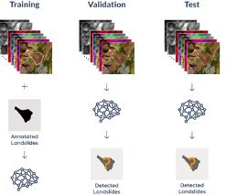
Figure 1. Landslide4Sense Dataset structure
Key findings from exploratory data analysis indicated there was clear separation of landslide-positive (1589 images) versus landslide-negative instances (1010 images). Moreover, effective normalization is validated through visualizations and statistical checks.
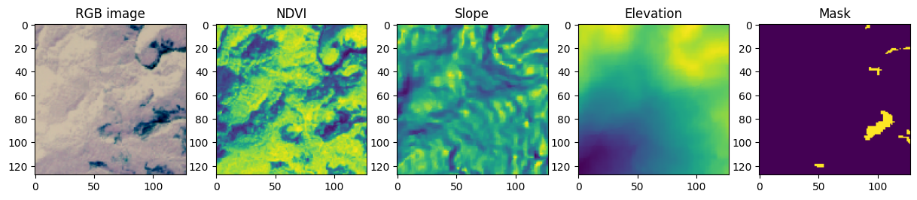
Figure 2. Multispectral patch sample showing a landslide-positive instance.

3.2 Data Loading and Preprocessing
Data was loaded using a customized Python function. The loading procedure automatically identifies and skips corrupted files, replacing missing data values (NaNs) with a very small constant (1e-6) to maintain numerical stability.
The input data was transformed into a robust six-channel representation comprising:

- Normalized Red, Green, and Blue (RGB) bands to standardize lighting conditions.
- Normalized Difference Vegetation Index (NDVI), calculated using the near-infrared
$NDVI = \frac{NIR - RED}{NIR + RED + 10^{-6}}$ (1)
- Individually Normalized Slope and Elevation channels to emphasize subtle terrain variations.

3.3. Methods
3.3.1. Baseline U-Net Architecture
The core segmentation backbone is a four-stage U‑Net comprising an encoder and decoder symmetrically connected via skip connections. We implemented three architectural variants:

- Encoder (Contracting path): Contains four blocks, each containing two (3x3) convolutional layers with ReLU (He initialization). For Dropout, blocks 1 - 2 use (0.1) whereas blocks 3 - 4 use (0.2). Max-Pooling was used for downsampling.
- Bottleneck: Two (3x3) convolutional layers (256 filters) with Dropout (0.3).
- Decoder (Expansive path): Four upsampling stages using (2x2) transposed convolutions, each followed by concatenation with its matching encoder feature map and a (3x3) convolution. Skip connections preserve spatial detail for precise segmentation.

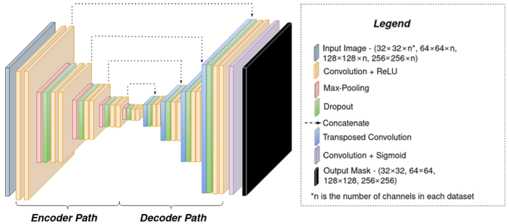
Figure 3. Baseline U‑Net architecture. Reproduced from Soares et al. [33].

3.3.2 ASPP‑Enhanced U‑Net Architecture
Building upon the baseline, an ASPP module was integrated into the bottleneck layer.

- The ASPP module captures multi-scale contextual information using parallel atrous convolutions with dilation rates (1, 6, 12, 18). The ASPP convolutions all use 256 filters.
- With a global average pooling branch present, multi-scale the model's ability to recognize complex landslide patterns is significantly improved.

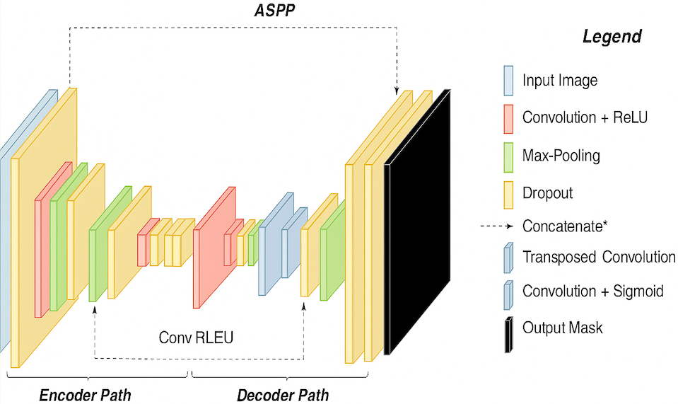
Figure 4. ASPP module within the U‑Net bottleneck.

3.3.3 Enhanced U-Net with ResNet50 + ASPP + CBAM architecture
- ResNet50 encoder: A powerful, pretrained convolutional neural network initially trained on ImageNet, adapted here by inflating its input layer to handle the six-channel input data. This leveraged pretrained weights for better feature extraction.
- Convolutional Block Attention Module (CBAM): Integrated at the bottleneck to dynamically emphasize important spatial and channel-wise features.
- The ASPP module described previously remained central, contributing to multiscale feature extraction.
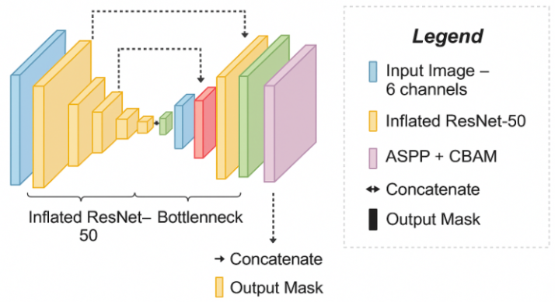
Figure 5. Enhanced U-Net model architecture.

3.4 Transfer Learning and Training Strategy
The third architecture in this study employs a U-Net variant enhanced with Atrous Spatial Pyramid Pooling (ASPP) and Convolutional Block Attention Modules (CBAM), using ResNet50 as the encoder backbone. Training was performed in two distinct phases, leveraging transfer learning to accelerate convergence and improve segmentation accuracy.

Phase 1: Frozen Encoder Pretraining
Initially, all layers of the ResNet50 encoder (identified by the prefix “resnet”) were frozen to preserve pre-trained ImageNet weights. Only the decoder, ASPP module, and CBAM blocks were trained during this phase. Training was conducted over 20 epochs using the Adam optimizer with a learning rate of 1 x 10⁻⁴ and a batch size of 16. Two callbacks were employed:
- EarlyStopping, monitoring the validation F1-score (val_f1_m) with a patience of 10 and restore_best_weights = True.
- ModelCheckpoint, saving the model weights corresponding to the highest validation F1-score.
Phase 2: Fine-Tuning the Full Network
In the second phase, all layers of the ResNet50 encoder were unfrozen to allow full-network training. Fine-tuning was performed for an additional 30 epochs using a reduced learning rate of 1 × 10⁻⁵ with the Adam optimizer. An additional ReduceLROnPlateau callback was introduced, which monitored validation loss and reduced the learning rate by a factor of 0.5 if no improvement was seen after 3 consecutive epochs. All models were trained using the Adam optimizer, employing a combined loss function (binary cross-entropy combined with Dice loss) defined as:

$L = BCE + (1- Dice)$ (2)
Dice Loss is used to penalize poor segmentation overlap during training:

$Dice Loss=1-Dice Coefficient$ (3)
3.5 Data Augmentation and Regularization
To enhance model generalization and robustness to spatial variance, online data augmentation was applied during training. Each input sample was randomly augmented with horizontal and vertical flips (50% probability), rotations within 30 degrees. To reduce overfitting, SpatialDropout2D was incorporated into the ASPP module (dropout rate = 0.2) and decoder blocks (dropout = 0.1). These regularization techniques were essential to improve the model’s ability to generalize across varied terrain and land cover conditions.

3.6 Interpretability and Explainability Techniques
Considering the real-world implications of landslide detection, interpretability was prioritized to ensure that model predictions were transparent and actionable. The following methods were implemented:

- Grad-CAM (Gradient-weighted Class Activation Mapping): Generates heat maps highlighting the model's areas of attention during prediction. This shows broadly where the network is looking when it predicts landslide pixels. It visualizes the convolutional layer activations weighted by their gradients. In this study, class-specific gradients were backpropagated to the final convolutional layer to produce coarse localization maps. These maps highlighted key regions influencing landslide prediction.

- Smooth Grad-CAM: A more stable variant of Grad-CAM. By adding Gaussian perturbations to the input and averaging the resulting heatmaps, it reduces speckle and highlights more stable attention regions. In this study we averaged multiple Grad-CAM maps with Gaussian noise perturbations (σ = 0.05).
- Guided Grad-CAM: Combines standard Grad-CAM with saliency maps to highlight precise regions significantly influencing the prediction. Element-wise multiplication of raw Grad-CAM and gradient saliency maps created sharper attention contours. A 75th-percentile threshold isolated high-importance regions for visualization.

- LIME (Local Interpretable Model-Agnostic Explanations): Explains individual predictions by approximating local model behavior using interpretable linear models and ranks the top-k superpixels driving each prediction. In this study, SLIC superpixels were used to segment input patches. A surrogate linear model approximated the prediction logic using 500 perturbations. Top-ranked superpixels consistently highlighted NIR and SWIR bands.

- Channel Sensitivity Analysis: Evaluated the impact of each input channel (RGB, NDVI, slope, elevation). This technique clearly revealed which spectral and terrain features were most critical for landslide detection. Each input channel was ablated (set to zero), and the resulting change in predicted output was measured. Slope and NIR bands showed the strongest impact on prediction behavior.

3.7 Evaluation Indices
The metrics considered for evaluating model performance were Precision, Recall, and F1-score and Dice Loss computed as follows:

- Precision measures the proportion of true positive predictions out of all positive predictions:
$Precision=\frac{TP}{TP+FP}$ (4)
- Recall measures the proportion of correctly predicted positive instances out of all actual positives:
$Recall=\frac{TP}{TP+FN}$ (5)
- F1-score is the harmonic mean of precision and recall, providing a balanced measure:

$F1=2×\frac{Precision×Recall}{Precision+Recall}$ (6)
- Dice Coefficient measures spatial overlap between predicted and actual segmentation masks:
$Dice Coefficient=\frac{2 × TP}{2× TP + FP + FN}$ (7)
- Dice Loss is used to penalize poor segmentation overlap during training:

$Dice Loss=1-Dice Coefficient$ (8)
4. Results

4.1. Evaluating Baseline U‑Net Performance
The plain U‑Net was trained for up to 100 epochs with early stopping around epoch 59. Loss fell from -0.65 to -0.40 in the first 10 epochs. The validation curves track the training curves closely, showing minimal overfitting. After epoch 20 the F1 curve levels off around -0.72.

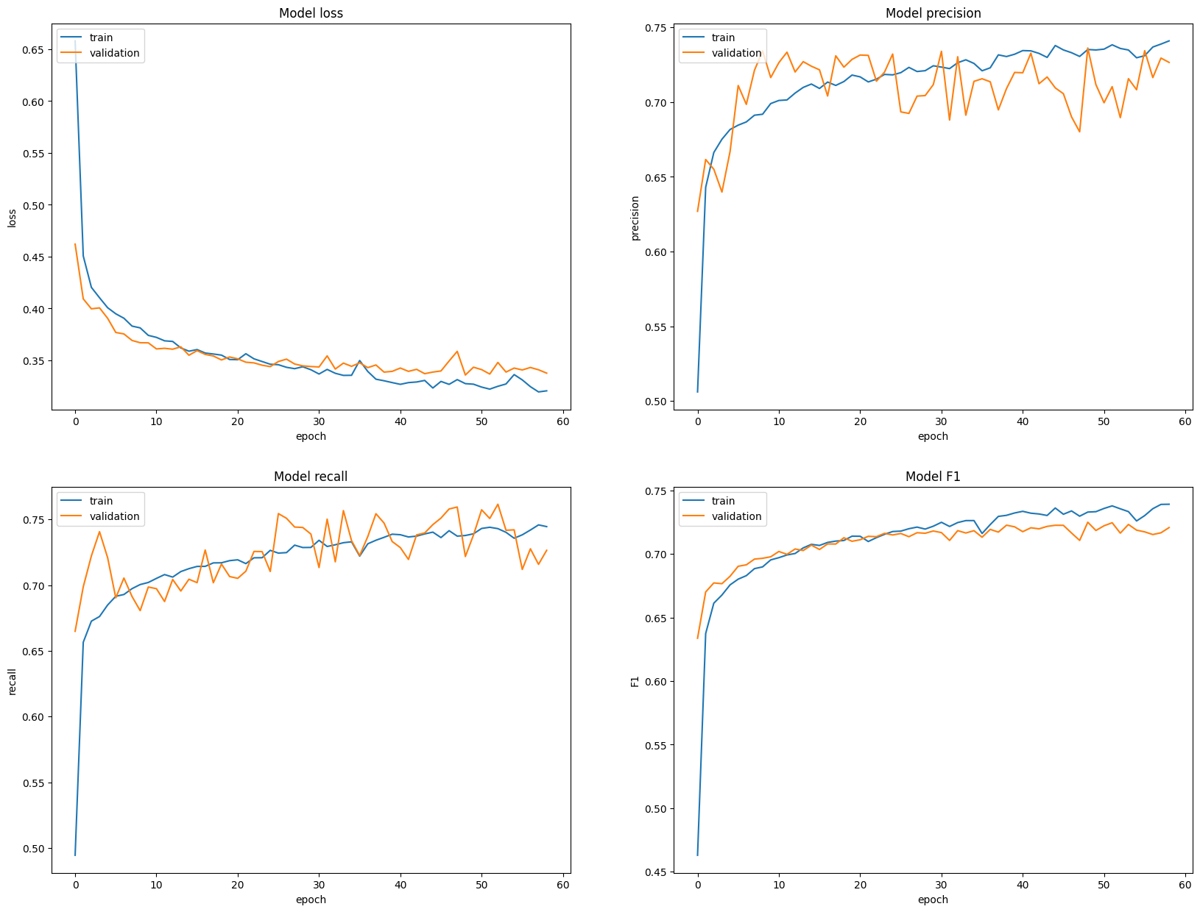
Figure 6. Metric curves for Baseline U‑Net.

4.2 Evaluating U‑Net with ASPP Performance
When integrating the Atrous Spatial Pyramid Pooling (ASPP) module in the bottleneck, we notice both train and validation losses settle near -0.35, compared to -0.37 for the baseline. Validation recalls climbs to -0.73 (baseline was -0.70), driving the F1 up. Minor oscillations in precision early on, but overall convergence is comparable to the baseline.
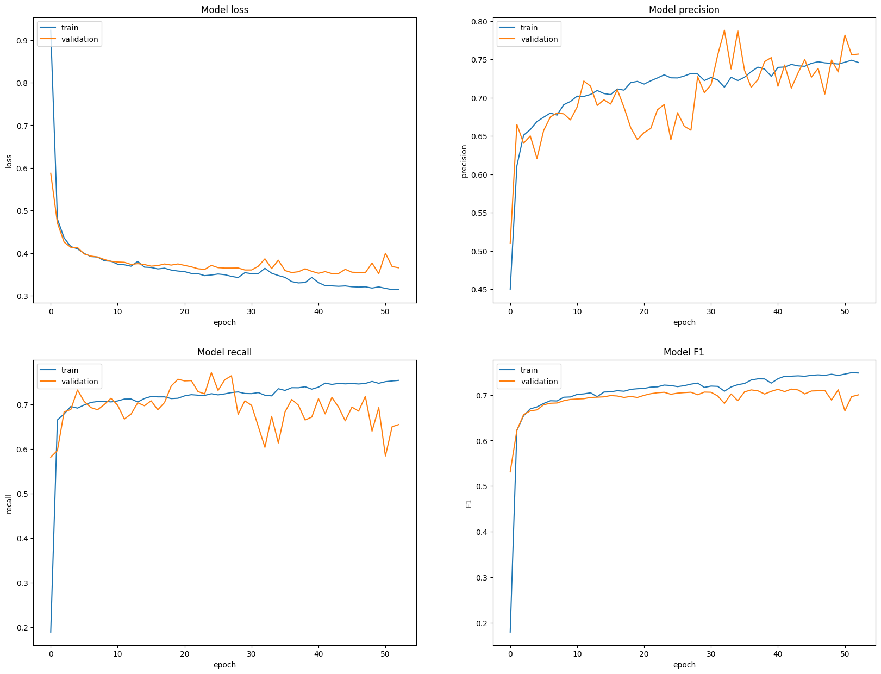
Figure 7. Metric curves for U‑Net with ASPP.
4.3. Evaluating Performance of Enhanced U‑Net with ResNet50 Encoder, CBAM and ASPP.
We swapped in a six‐channel-inflated ResNet50 pretrained on ImageNet, and added CBAM. The Encoder was frozen for 20 epochs, then fine‑tuned all layers at a lower LR for 30 epochs. The frozen-unfrozen transition around epoch 20 introduces a bit more volatility, but the model quickly re‑stabilizes. Both approach -0.74 and -0.70, respectively, on validation. Peaks around -0.71 to -0.72, a modest yet consistent bump over ASPP-only.
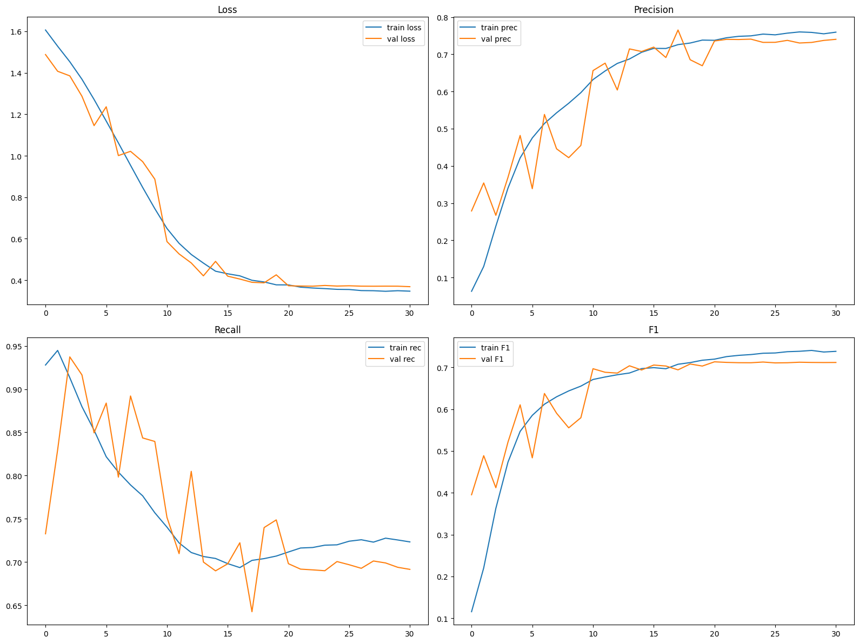
Figure 8. Metric curves for Enhanced U‑Net with ResNet50, CBAM and ASPP.
Table 1. Summary of final validation metrics.
Model Variant | F1 | Precision | Recall | Loss
Baseline U‑Net | 0.67 | 0.74 | 0.64 | 0.43
U‑Net + ASPP | 0.69 | 0.74 | 0.69 | 0.35
Enhanced U‑Net with ResNet50 Encoder | 0.71 | 0.74 | 0.70 | 0.32

From Table 1, we can see precision stability (-0.74 across all models) which means we are not trading more false positives for recall. Recall gains (+5 points with ASPP, +1 more with CBAM and ResNet50) which drive the overall F1 lift. Cumulative improvements show how multiscale context and pretrained representations complement each other.

4.4. Deep‑Dive into Interpretability Tools

To ensure our model is not just memorizing the data, we successfully applied six complementary interpretability methods to the final Enhanced U‑Net model. The bright yellow islands in the mask align with exposed terrain in the RGB image. Our model correctly identifies the two main landslide patches and one small outlier. Our interpretability techniques tell us more.

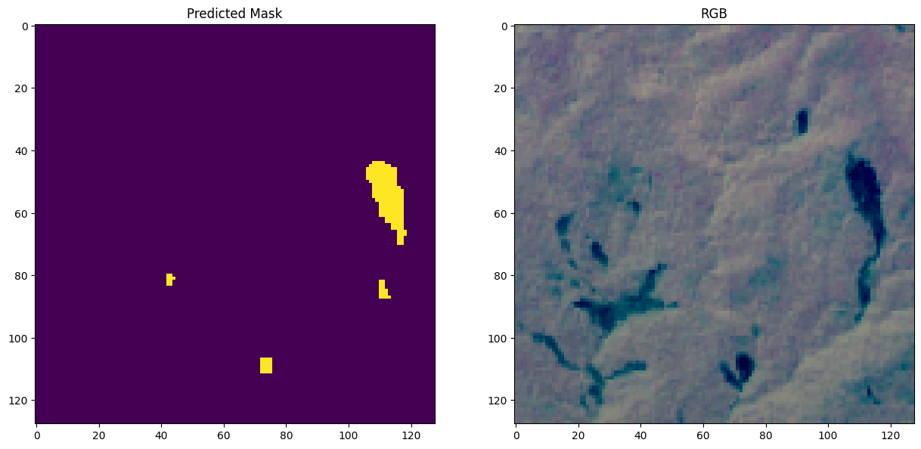
Figure 9. Predicted mask (left) and RGB input patch (right).
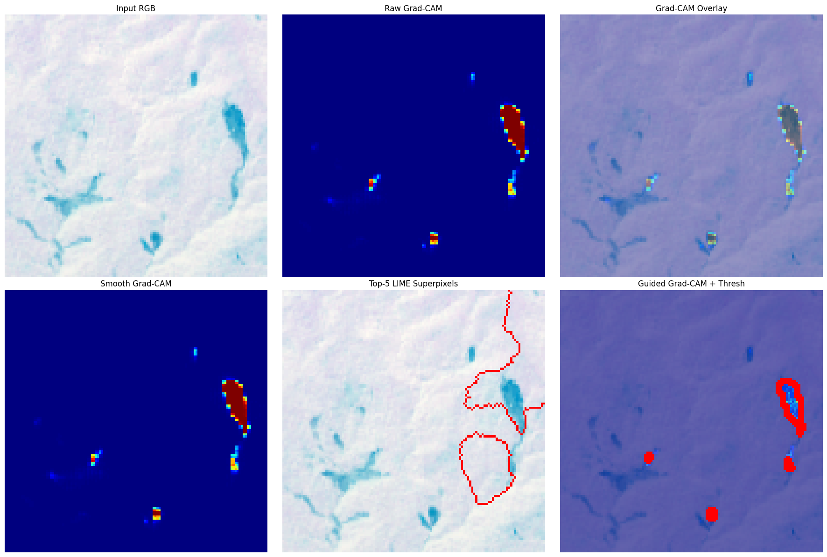

Figure 10. Interpretability analysis using a variety of Grad-CAM overlays and LIME

From Figure 10, we can see that Raw Grad‑CAM highlights the convolutional feature maps that most influence the landslide pixels. Overlay shows these hot regions superimposed on the terrain, centering on slope edges and vegetation scars. Smooth Grad‑CAM averages multiple noisy saliency maps to yield a cleaner heatmap, still focused on the same areas. LIME outlines the top‑5 superpixels that drive the prediction; these red contours trace the mask islands perfectly. Guided Grad‑CAM + Threshold combines pixel‑level gradients with saliency, then thresholds to draw crisp contours around the predicted landslide blobs

5. Discussion
Upon conducting a channel sensitivity analysis, it was found that our models' high sensitivity to the red and slope channels indicates that soil colour and terrain gradient are the strongest cues. On the other hand, very low sensitivity to elevation suggests absolute height is less important than local slope. Whereas moderate sensitivity of NDVI shows vegetation health also guides the model, but less so than slope.
The Landslide4Sense dataset exhibits foreground-background imbalance. It showed 1589 out of 2599 patches containing any landslide pixels. Furthermore, in each (128 x 128) patch, landslide pixels often represent <10 % of total pixels. Research directions to tackle imbalance include: Focal Tversky loss to adjust the weight on false negatives vs. false positives. Boundary‑aware losses is another option to emphasize the edges of small objects. Oversampling rare patches is a solution to get more landslide‑heavy regions into the model.
The introduction of multiscale context via ASPP and the selective feature weighting of CBAM yielded consistent gains in both segmentation accuracy and interpretability. Enhanced models not only achieved higher F1-scores but also provided heatmaps and explanations aligned with geological features such as slope gradients and soil moisture patterns. This synergy between performance and transparency positions our framework as a practical tool for landslide risk assessment in Ghana. Potential future directions include exploring lightweight attention mechanisms to reduce inference time and integrating additional environmental covariates.

6. Conclusions
This study presented a progressively enhanced and interpretable deep learning framework for landslide detection in Ghana, using multispectral Sentinel-2 imagery and topographic data. Starting from a baseline U-Net, performance was incrementally improved through the integration of Atrous Spatial Pyramid Pooling (ASPP), a ResNet50 encoder, and a Convolutional Block Attention Module (CBAM). These architectural upgrades improved the validation F1-score from 0.67 to 0.71, demonstrating better segmentation accuracy in identifying landslide-prone regions. Beyond accuracy, a central contribution of this work is its focus on interpretability. Through Grad-CAM variants, LIME, and channel-sensitivity analysis, we showed that the model consistently focuses on physically meaningful cues particularly slope, soil color (Red band), and vegetation health (NDVI). This transparency helps bridge the gap between high-performing deep networks and stakeholder trust, a critical step for deploying AI in disaster risk reduction. The model also handled common challenges in real-world segmentation, such as class imbalance and sparse foreground representation. Although landslide pixels constituted less than 10% of each image in many cases, strategic training choices such as careful normalization, data augmentation, and early stopping helped stabilize learning. However, high sensitivity to slope and low reliance on elevation suggest that the model prioritizes relative terrain features, aligning with geomorphological intuition. While the architecture is promising, its current scope is limited to Ghanaian terrain and a single annotated dataset. Broader validation, improved handling of small-object segmentation, and domain-adaptive training will be essential for real-world deployment.
Author Contributions: Conceptualization, N.K.O.-O.; methodology, N.K.O.-O. and E.N.; software, N.K.O.-O.; validation, N.K.O.-O.; formal analysis, N.K.O.-O.; investigation, N.K.O.-O. and E.N.; data curation, N.K.O.-O.; writing-original draft preparation, N.K.O.-O.; writing-review and editing, E.N.; visualization, N.K.O.-O.; supervision, J.A.I. and J.A.; academic guidance, J.A.I. and J.A. All authors have read and agreed to the published version of the manuscript.
Funding: This research received no external or institutional funding.
Data Availability Statement: The Landslide4Sense dataset used in this study is publicly available at: https://github.com/iarai/Landslide4Sense-2022
Acknowledgements: The authors would like to thank Dr. Jeremiah Ayok Ishaya and Julius Amegadzie for their supervision, mentorship, and academic support. This research was carried out by student researchers Nana Kwaku Osei-Opoku (lead author) and Ebenezer Nortey as part of their undergraduate work at Academic City University. The study benefited from open-source tools including Google Colab, TensorFlow, Visual Studio Code, Matplotlib, and QGIS. The authors also acknowledge the creators of the Landslide4Sense benchmark dataset.
Conflicts of Interest: The authors declare no conflict of interest.

7. References
- Fidan, S.; Tanyaş, H.; Akbaş, A.; Lombardo, L.; Petley, D.N.; Görüm, T. Understanding fatal landslides at global scales: A summary of topographic, climatic, and anthropogenic perspectives. Nat. Hazards 2024, 1–24. https://doi.org/10.1007/s11069-024-06487-3.
- Chae, B.-G.; Park, H.-J.; Catani, F.; Simoni, A.; Berti, M. Landslide prediction, monitoring and early warning: A concise review of state-of-the-art. Geosci. J. 2017, 21, 1033–1070. https://doi.org/10.1007/s12303-017-0034-4.
- Jemec-Auflič, M.; et al. Landslide monitoring techniques in the Geological Surveys of Europe. Landslides 2023, 20, 1–15. https://doi.org/10.1007/s10346-022-02007-1.
- Pandey, V.K.; Tripathi, A.K.; Sharma, K.K. Implications of landslide inventory in susceptibility modeling along a Himalayan highway corridor, India. Phys. Geogr. 2021, in press, 1–24. https://doi.org/10.1080/02723646.2021.1872857.
- Abancó, C.; Bennett, G.L.; Matthews, A.J.; Matera, M.A.M.; Tan, F.J. The role of geomorphology, rainfall and soil moisture in the occurrence of landslides triggered by 2018 Typhoon Mangkhut in the Philippines. Nat. Hazards Earth Syst. Sci. 2021, 21, 1531–1550. https://doi.org/10.5194/nhess-21-1531-2021.
- Ye, P.; Yu, B.; Chen, W.; Liu, K.; Ye, L. Rainfall-induced landslide susceptibility mapping using machine learning algorithms and comparison of their performance in Hilly area of Fujian Province, China. Nat. Hazards 2022, 113, 965–995. https://doi.org/10.1007/s11069-022-05332-9.
- Yuan, Q.; et al. Deep learning in environmental remote sensing: Achievements and challenges. Remote Sens. Environ. 2020, 241, 111716. https://doi.org/10.1016/j.rse.2020.111716.
- Bajwa, A. Image Segmentation with U‑Net. Analytics Vidhya 2022. Available online: https://www.analyticsvidhya.com [Accessed: Aug. 4, 2024].
- Ronneberger, O.; Fischer, P.; Brox, T. U‑Net: Convolutional Networks for Biomedical Image Segmentation. arXiv 2015, arXiv:1505.04597.
- Liu, F.; Wang, L. UNet-based model for crack detection integrating visual explanations. Constr. Build. Mater. 2022, 322, 126265. https://doi.org/10.1016/j.conbuildmat.2021.126265.
- Yang, Z.; Qi, W.; Xu, C.; Shao, X. Exploring deep learning for landslide mapping: A comprehensive review. China Geol. 2024, 7, 330–350. https://doi.org/10.31035/cg2024032.
- Soares, L.P.; Dias, H.C.; Grohmann, C.H. Landslide Segmentation with U-Net: Evaluating Different Sampling Methods and Patch Sizes. arXiv 2020, arXiv:2007.06672.
- Ghaffarian, S.; Taghikhah, F.R.; Maier, H.R. Explainable artificial intelligence in disaster risk management: Achievements and prospective futures. Int. J. Disaster Risk Reduct. 2023, 98, 104123. https://doi.org/10.1016/j.ijdrr.2023.104123.
- Gupta, D. Interpretable Machine Learning Methods for Landslide Analysis. MIT Theses 2022.
[Online]. Available: https://doi.org/10.15760/hauserthesis. [Accessed: Oct. 22, 2025].
- Ghorbanzadeh, O.; Xu, Y.; Ghamisi, P.; Kopp, M.; Kreil, D. Landslide4Sense: Reference Benchmark Data and Deep Learning Models for Landslide Detection. ResearchGate 2022.
- Ghorbanzadeh, O.; Crivellari, A.; Ghamisi, P.; Shahabi, H.; Blaschke, T. A comprehensive transferability evaluation of U-Net and ResU-Net for landslide detection from Sentinel-2 data. Sci. Rep. 2021, 11, 13586. https://doi.org/10.1038/s41598-021-94190-9.
- Wang, J.; Zhang, Q.; Xie, H.; Chen, Y.; Sun, R. Enhanced dual-channel model based with improved U-Net++ network for landslide monitoring and region extraction in remote sensing images. Remote Sens. 2024, 16, 2990. https://doi.org/10.3390/rs16162990.
- Fang, C.; Fan, X.; Zhong, H.; Lombardo, L.; Tanyas, H.; Wang, X. A novel historical landslide detection approach based on LiDAR and lightweight attention U-Net. Remote Sens. 2022, 14, 4357. https://doi.org/10.3390/rs14174357.
- Vega, J.; Hidalgo, C. Evaluation of U-Net transfer learning model for semantic segmentation of landslides in the Colombian tropical mountain region. MATEC Web Conf. 2024. https://doi.org/10.1051/matecconf/202439619002.
- Nava, L.; Singh, R.P.; Meena, S.R.; Monserrat, O.; Catani, F. Rapid mapping of landslides on SAR data by Attention U-Net. Remote Sens. 2022, 14, 1449. https://doi.org/10.3390/rs14061449.
- Nhu, V.-H.; et al. Landslide susceptibility mapping using machine learning algorithms and remote sensing data in a tropical environment. Int. J. Environ. Res. Public Health 2020, 17, 4933. https://doi.org/10.3390/ijerph17144933.
- Le, X.-H.; Choi, C.; Eu, S.; Yeon, M.; Lee, G. Quantitative evaluation of uncertainty and interpretability in machine learning-based landslide susceptibility mapping through feature selection and explainable AI. Front. Environ. Sci. 2024, 12, 1424988. https://doi.org/10.3389/fenvs.2024.1424988.
- Hou, C.; et al. A transfer learning approach for landslide semantic segmentation based on visual foundation model. IEEE J. Sel. Top. Appl. Earth Obs. Remote Sens. 2025, PP, 1–14. https://doi.org/10.1109/JSTARS.2025.3559884.
- Qin, S.; et al. Landslide detection from open satellite imagery using distant domain transfer learning. Remote Sens. 2021, 13, 3383. https://doi.org/10.3390/rs13173383.
- Liu, B.; Wang, W.; Wu, Y.; Gao, X. Attention Swin Transformer U-Net for landslide segmentation in remotely sensed images. Remote Sens. 2024, 16, 4464. https://doi.org/10.3390/rs16234464.
- Dong, Z.; An, S.; Zhang, J.; Yu, J.; Li, J.; Xu, D. L-Unet: A landslide extraction model using multi-scale feature fusion and attention mechanism. Remote Sens. 2022, 14, 2552. https://doi.org/10.3390/rs14112552.
- Chen, H.; et al. A landslide extraction method of channel attention mechanism U-Net network based on Sentinel-2A remote sensing images. Int. J. Digit. Earth 2023, 16, 552–577. https://doi.org/10.1080/17538947.2023.2177359.
- Wei, R.; Ye, C.; Sui, T.; Zhang, H.; Ge, Y.; Li, Y. A feature enhancement framework for landslide detection. Int. J. Appl. Earth Obs. Geoinf. 2023, 124, 103521. https://doi.org/10.1016/j.jag.2023.103521.
- Zhu, X.; Zhang, Z.; He, Y.; Wang, W.; Yang, S.; Hou, Y. LandslideNet: A landslide semantic segmentation network based on single-temporal optical remote sensing images. Adv. Space Res. 2024, 74, 4616–4638. https://doi.org/10.1016/j.asr.2024.07.038.
- Kaushal, A.; Gupta, A.K.; Sehgal, V.K. A semantic segmentation framework with UNet-pyramid for landslide prediction using remote sensing data. Sci. Rep. 2024, 14, 79266. https://doi.org/10.1038/s41598-024-79266-6.
- Chowdhury, S.; Mirzaei, G. Hybridization of Attention U‑Net with repeated atrous spatial pyramid pooling for improved brain tumor segmentation. arXiv 2025.
- Soares, L.P.; Dias, H.C.; Garcia, G.P.B.; Grohmann, C.H. Landslide Segmentation with Deep Learning: Evaluating Model Generalization in Rainfall‑Induced Landslides in Brazil. Remote Sens. 2022, 14(9), 2237. https://doi.org/10.3390/rs14092237.

